The HAS raw binary corrections output in real-time by the SINO GNSS receiver were pushed to the NTRIP Caster. Users can perform real-time buffering of research data using the RTKLIB plugin STRSVR. It is worth noting that this differs from Galileo broadcasting HAS data in RTCM format over the Internet. Its purpose is to facilitate more researchers in testing the HASPPP.

NOTES: The source code for HASPPP has been uploaded to the QQ group (651080705).

Fig. 1 depicts the configuration of receiving NTRIP data using the STRSVR plugin in RTKLIB. Below is the account currently in use:

NTRIP Caster Address: 42.51.39.39;

Port: 20198;

Mountpoint: HAS;

User ID: has;

Password: 99.

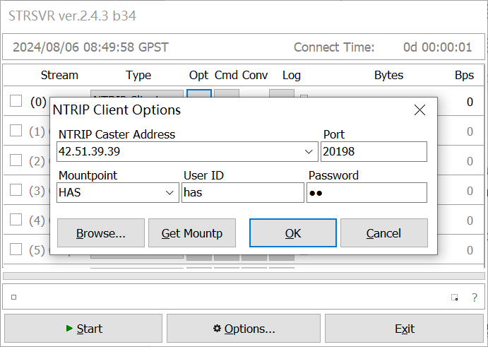

Fig. 1 Receiving NTRIP data via the STRSVR plugin